1)

#include <bits/stdc++.h>

using namespace std;

int main()

{

map <int,string>Students;

Students.insert(pair<int,string>(200,"Alice"));

Students.insert(pair<int,string>(201,"John"));

cout<<"The size of map:"<<Students.size()<<endl;

map <int,string>::iterator itr;

for(itr=Students.begin();itr!=Students.end();itr++)

{

cout<<"Roll number:"<<itr->first<<endl;

cout<<"Name:"<<itr->second<<endl;

}

return 0;

}

Output:

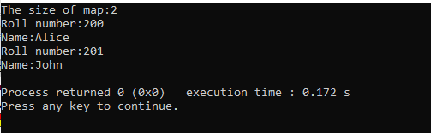

2)

#include <bits/stdc++.h>

using namespace std;

int main()

{

map <int,int>m;

m.insert(pair<int,int>(5,6));

m.insert(pair<int,int>(8,7));

m.insert(pair<int,int>(1,3));

map <int,int>::iterator itr;

cout<<"Map data"<<endl;

for(itr=m.begin();itr!=m.end();itr++)

{

cout<<itr->first<<"->"<<itr->second<<endl;

}

cout<<"Changing element with key ==5"<<endl;

itr=m.find(5);

if(itr!=m.end())

{

itr->second=10;

}

cout<<"Modified map data "<<endl;

for(itr=m.begin();itr!=m.end();itr++)

{

cout<<itr->first<<"->"<<itr->second<<endl;

}

return 0;

}

Output:

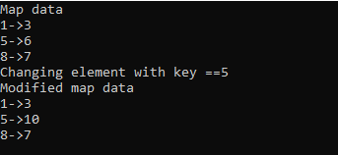

3)

#include <bits/stdc++.h>

using namespace std;

int main()

{

map <int,string>Students;

Students.insert(pair<int,string>(200,"Alice"));

Students.insert(pair<int,string>(201,"John"));

map <int,string>::iterator itr;

itr=Students.find(201);

if(itr!=Students.end())

{

cout<<"Found"<<endl;

cout<<itr->first<<"->"<<itr->second;

}

return 0;

}

Output:

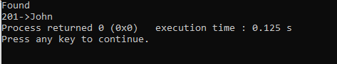

4)

#include <bits/stdc++.h>

using namespace std;

int main()

{

map <string,int>my_map;

my_map.insert(pair<string,int>("cow",1));

my_map.insert(pair<string,int>("cat",2));

my_map.insert(pair<string,int>("lion",3));

map <string,int>::iterator itr;

for(itr=my_map.begin();itr!=my_map.end();itr++)

{

cout<<itr->first<<"->"<<itr->second<<endl;

}

cout<<"Finding and deleting element cat in map"<<endl;

itr=my_map.find("cat");

if(itr!=my_map.end())

{

cout<<"Found"<<endl;

cout<<itr->first<<"->"<<itr->second<<endl;

cout<<"Deleting element of cat"<<endl;

my_map.erase(itr);

}

for(itr=my_map.begin();itr!=my_map.end();itr++)

{

cout<<itr->first<<"->"<<itr->second<<endl;

}

return 0;

}

Output:

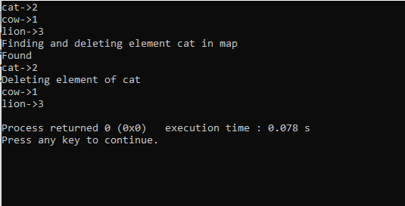

5)

#include <iostream>

#include <fstream>

using namespace std;

int main() {

fstream file;

file.open("abc.txt", ios::out);

if (!file) {

cout << "File not created!";

}

else {

cout << "File created successfully!";

string s;

cout<<"\nEnter data: ";

cin>>s;

file << s;

cout<<"data added succesfully";

file.close();

}

return 0;

}

Output:

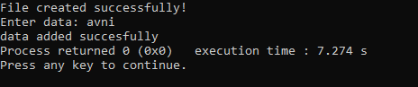

6)

#include <iostream>

#include <fstream>

using namespace std;

int main() {

fstream file;

file.open("abc.txt", ios::in);

if (!file) {

cout << "File not opened!";

}

else {

string s;

cout << "File opened succesfully"<<endl;

while(!file.eof())

{

file>>s;

cout<<s<<" ";

}

file.close();

}

return 0;

}

Output:

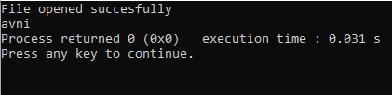

7)

#include <iostream>

#include <fstream>

using namespace std;

int main() {

fstream file;

string s,s1;

cout<<"Enter file name with extension to be copied: ";

cin>>s;

file.open(s, ios::in);

if (!file) {

cout << "File not exist"<<endl;

}

else {

cout << "File opened succesfully"<<endl;

cout<<"enter the file name with extension to copy data : ";

cin>>s1;

fstream f;

f.open(s1, ios::out);

if (!f) {

cout << "File not created";

}

else

{

cout<<"File created succesfully"<<endl;

while(!file.eof())

{

file>>s;

f<<s<<" ";

}

cout<<"Data copied succesfully"<<endl;

}

file.close();

f.close();

}

cout<<"Showing copied data in new file "<<endl;

fstream f;

f.open(s1, ios::in);

if (!f) {

cout << "File not created";

}

else

{

while(!f.eof())

{

f>>s;

cout<<s<<" ";

}

f.close();

}

return 0;

}

Output:

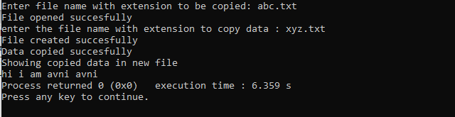

8)

#include <iostream>

#include <fstream>

#include <stdio.h>

using namespace std;

int main()

{

char one[30], two[30], three[30], ch;

fstream f1, f2, f3;

cout << "Enter the Name of First Source file:";

gets(one);

cout << "Enter the Name of Second Source file:";

gets(two);

f1.open(one, fstream::in);

f2.open(two, fstream::in);

if ((!f1) || (!f2))

{

cout << "\nError Occurred";

return 0;

}

else

{

cout << "Enter the Name of Target File:";

gets(three);

f3.open(three, fstream::out);

if (!f3)

{

printf("\nError Occurred");

return 0;

}

else

{

while (f1 >> noskipws >> ch)

f3 << ch;

f3 << "\n";

while (f2 >> noskipws >> ch)

f3 << ch;

cout << "\nContent of Two File Merged Successfully into Third!";

}

f3.close();

cout<<"\nshowing content of third file:"<<endl;

f3.open(three, fstream::in);

while (f3 >> noskipws>> ch)

{

cout<<ch;

}

}

f1.close();

f2.close();

f3.close();

return 0;

}

Output:

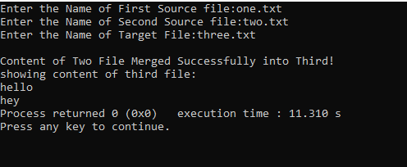

9)

#include <iostream>

#include <stdio.h>

using namespace std;

int main()

{

int status;

char fileName[20];

cout << "Enter the Name of File: ";

cin >> fileName;

status = remove(fileName);

if (status == 0)

cout << "\nFile Deleted Successfully!";

else

cout << "\nFail to delete file!";

cout << endl;

return 0;

}

Output

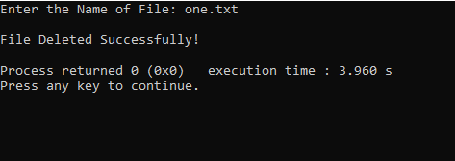

10)

#include <iostream>

#include <fstream>

using namespace std;

int main()

{

char data[100];

fstream f1;

f1.open("one.txt");

cout << "Writing to the file" << endl;

cout << "Enter your first name: ";

cin>>data;

f1 << data <<' ';

cout << "Enter your second name: ";

cin >> data;

f1 << data << endl;

f1.close();

f1.open("one.txt");

cout << "Reading from the file" << endl;

f1 >> data;

cout << "Your's first name: "<<data<<endl;

f1 >> data;

cout << "Your's second name: "<< data << endl;

f1.close();

return 0;

}

Output:

